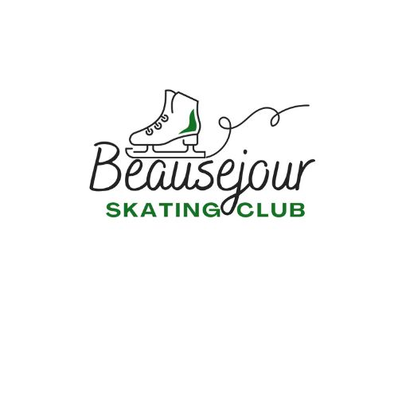

2025-2026

CANSKATE HANDBOOK

 Beausejour Skating Club



[This Photo](https://en.wikipedia.org/wiki/File:Instagram_logo_2016.svg) by Unknown Author is licensed under [CC BY-SA](https://creativecommons.org/licenses/by-sa/3.0/)

<https://beausejourskatingclub.uplifterinc.com/>

Email: [beausejourskatingclub@gmail.com](mailto:beausejourskatingclub@gmail.com)

**COACHING STAFF**

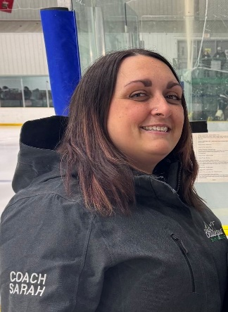**SARAH MURKIN-DEBUCKELAERE**

**Head Professional Coach**

Coach Sarah has been coaching for 22 years. She is a Regional NCCP Coach and boasts her CanPower certification. She has been coaching CanSkate with Beausejour Skating Club for over 15 years.

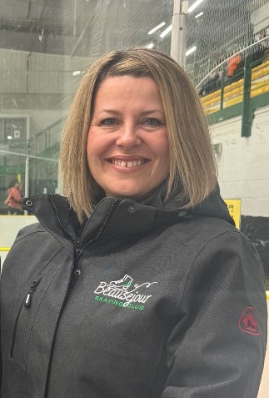**SYBIL CARELLO**

**Professional Coach**

Coach Sybil has been coaching for 21 years. She is a Provincial NCCP Coach and boasts her CanPower certification. She has been coaching CanSkate with BSC for over 10 years.

**Program Assistants**

Program Assistants are BSC skaters/other volunteers who volunteer to assist on CanSkate sessions.

PA’s are not coaches but must complete PA training and are there to assist skaters and coaches. Most of these skaters that have either graduated out of our CanSkate program or are a part of our competitive skating program. These volunteers give their time to help the Coaches on and off the ice and can be identified by their grey vests. They assist with warm up and cool down, help the younger skaters where needed, can be a buddy to a nervous skater, help with set up by bringing out the teaching aids and toys and help put them away again. Our PAs are a great addition to making our CanSkate sessions successful!

If you have any questions about our PA’s, please discuss with our professional coaches.

**CanSkate Program Times**

**Beausejour Sportsplex**

**Friday 4:15-5:00 pm**

**Sunday 10:30 -11:15 am**

**What is CanSkate?**

CanSkate is a “learn to skate” program. The fundamentals of skating are taught to prepare skaters for various sports including, STARSkate program, CanPowerSkate, Hockey, Ringette or for a lifetime of recreational skating.

**CanSkate Objectives**

• To provide basic skating instruction in a group situation.

• To introduce skaters to the fundamentals of movements of skating in a safe, fun environment.

• To develop balance, coordination and rhythm through music.

• To enable skaters to move through the Skate Canada system smoothly.

• To encourage lifelong participation in skating.

• To promote physical fitness.

**CLUB EXPECTATIONS**

Our club keeps the safety of all our members – skaters, coaches, parents and board members – a top priority. Our rules and expectations exist to ensure that your child and all members of Beausejour Skating Club can safely enjoy the club’s skating programs in a fun and respectful environment.

**CLUB RULES**

1. Fees must be paid prior to the commencement of the skating session.

2. All refund requests must be submitted to the Board in writing and adhere to the refund policy outlined in detail on our website.

3. Proper skating attire should be worn by all skaters. Please see the section regarding clothing for details.

4. CanSkaters up to and including Stage 5 MUST wear a CSA-approved hockey helmet as per Skate Canada’s Helmet Use Policy. (this may be extended at the discretion of the coaches).

5. No eating or chewing gum while on the ice. Please make sure that your child does not have anything in their mouth before going on to the ice.

6. Coaches are in charge of all skaters while on the ice.

7. It is important that an adult remain in charge of your skater. If this is not going to be yourself, please indicate to the Club/CanSkate Coordinator who will be responsible for your child in case of emergency.

8. Parents who wish to discuss their child’s progress with the coach must do so after sessions or when coaches are off the ice. Please do not interrupt program time.

9. Your child will be told to leave the ice if they choose to disregard the rules during a skating session. It is not the responsibility of the Coach/Program Assistants to discipline the skaters.

10. Dressing rooms must be kept clean.

11. Skaters are allowed to leave the ice to use the washrooms or warm up if necessary but must make a PA/Coach aware prior to leaving the ice.

12. Parents are not allowed on the ice at any time due to insurance reasons. If you need to take your child off the ice, please get the attention of one of the coaches or program assistants. Please do not go on the ice.

13. If you have any concerns, comments, or suggestions please direct them to the Board of Directors. If you wish this concern to be discussed by the entire Board at a meeting, please put it in writing and direct it to the President.

**ICE SAFETY RULES**

Please go over the ice rules with your skater so they are aware.

* Get up immediately after you fall, it is very dangerous to remain on the ice surface.
* No food or drink (except water bottles) permitted on/near the ice surface by skaters
* On-ice kicking the ice, disrespectful or uncooperative behavior during sessions will not be tolerated.
* ONLY SKATERS AND COACHES OR AUTHORIZED PERSONS MAY ENTER THE ICE AREA/PLAYER BOX/MUSIC BOX.
* Skaters must clear the ice promptly at the end of their skating session

**PLEASE NOTE: A Board Member or Coach has the authority to remove any skater from the ice for inappropriate conduct as per policy.**

**EQUIPMENT & ATTIRE**

**Equipment Checklist:**

* **CSA Approved Hockey Helmet** (Bicycle and Ski Helmets are NOT allowed- see pictures below)

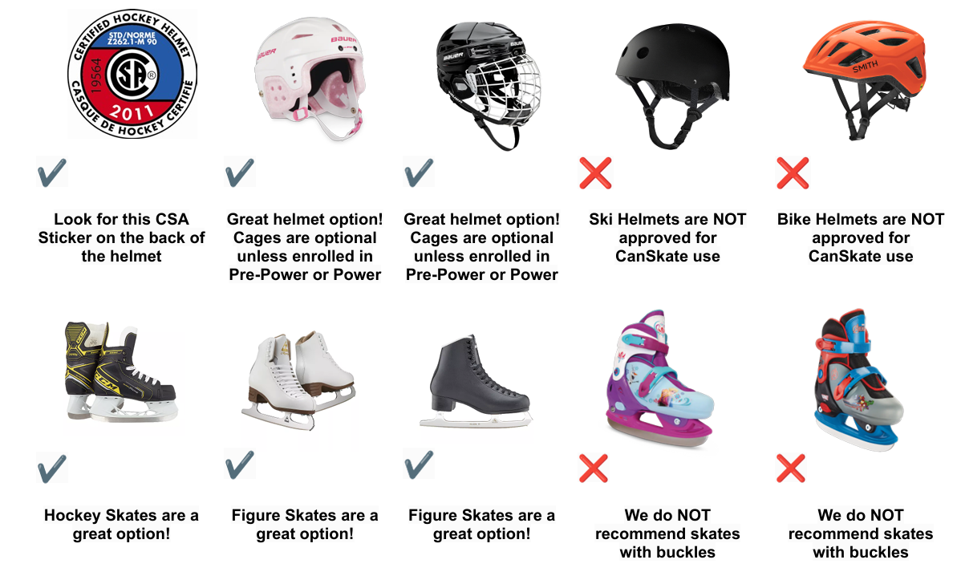

Please Note: Younger skaters are encouraged to wear cages to protect their faces while learning to skate!

* **Skates** (Skates with laces are recommended, no buckles - see pictures below)

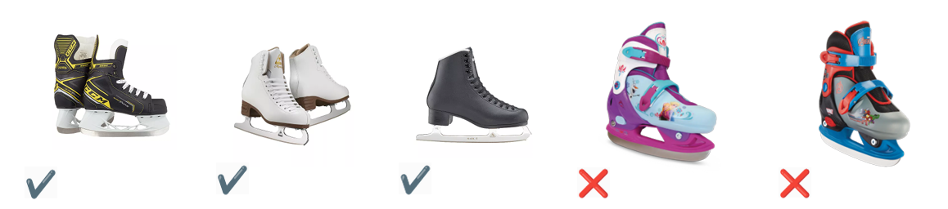

* **How to Fit Skates - (Beginners and CanSkate)**

Getting a pair of skates that fit well and provide good support are essential to an enjoyable and successful skating season.

**Here are a few do’s and don’ts for skate shopping:**

* Do NOT buy skates that are too large, thinking your child will grow into them. If you

anticipate a growth spurt, you could buy no more than a half-size larger pair of skates and wear a thicker sock in them at first.

**Ideally, a thin sock or better yet leotards/tights should be worn in skates. Feet actually stay warmer!!!**

* Avoid skates that are molded out of plastic – they do not allow for the kind of ankle flexibility needed.
* If buying used skates, be sure there is some sharpening steel left on the blade. There should be a slight curve to the blade, so if it appears to be flat, its lifespan is complete and won’t sharpen/skate properly.

**Follow these steps for trying on skates:**

1. Unlace the boot very loosely and pull the tongue forward as far as the laces go.

2. While seated, insert the foot. Slide it all the way forward, being sure to keep toes flat.

3. Check to see if you can insert your index finger behind the heel. Ideally, it’s a tight squeeze -- only half a finger width is recommended. If you can get a full finger in, the boot is too long. If you can’t fit it in at all, the boot may be too small.

4. Now kick the heel to the very back of the boot. Curl the tongue in around the foot and ankle and do up the laces firmly, but not too tightly. If there is extra lace, do NOT wrap it around the ankle. You can go back down and run it up the hooks of the skate one more time, and/or double knot it at the top.

5. If the sides of the skate are stretched apart so they don’t cover the tongue, the boot is too

narrow/small. If the sides of the skate appear too close together (almost meeting across the

tongue), or if the skate appears to buckle or bubble near the toe seam, the boot is too

wide/long.

6. After lacing up both skates, stand up in them. Toes of both feet should be laying flat and NOT touching the ends of either skate.

7. ALWAYS Take a walk in the skates before you come to the rink the first time. Heels of both feet should NOT lift at all, and should be snugly in the skate. This is the most vital of fitting steps!!!! The heel should always stay snugly in the heel cup of the skate.

8. The skater should be able to stand up completely straight, without any leaning in or out

around the ankle area. If the ankles are buckling while standing, the skates do NOT have

enough support.

9. If the skater can walk comfortably, supported through the ankle area, with the heels

snugly in the heel cups and no toes touching the fronts of the skates, you have found a

good fit!!!

**Caring for Skates**

* The most important part of caring for skates is ensuring that your blades are totally dry when finished on the ice, and that skates are aired/dried out once you are at home.
* Skate guards should always be worn when skaters are anywhere but on the ice or on the rubber matting at the ice’s entry.
* Blades need to be sharpened on a fairly regular basis, depending on how often they are used. To check if a blade needs sharpening, run your thumbnail over it lightly – if it doesn’t create a bit of “nail dust”, it needs to be sharpened. As well, if there are any nicks in the edges of the blades, they should be sharpened.
* **Skating Appropriate Clothing**
* Clothing should provide warmth, allow for movement and provide some protection from falls.
* Avoid clothing that is too bulky or restrictive.
* Snowsuits are not recommended.
* Wind pants or track pants over long comfortable pants are recommended to keep your skater warm and dry.
* Mittens and gloves are a must. A backup pair should be provided in case they get wet.
* Long scarves are not to be worn.
* Long hair must be tied back/not in skaters’ line of vision.
* Coaches use markers and bingo dabbers to draw circuits on ice. This can stain clothes and should be taken into consideration when choosing what to wear.

**REMINDER – Skates should be tied snugly enough to provide good ankle support, however should not be wrapped around the ankles as this does not allow for the bend your skater will need to learn good skating technique.**

**What to Expect During the First Week of CanSkate:**

**Arriving at the Arena:**

The first week is always a bit chaotic! On the first day of your session, it is suggested you arrive 15-minutes prior your skaters’ session.

Each week, you will check the white board in the lobby area to determine the dressing room that has been assigned to CanSkate at the Sportsplex.

You may use this dressing room to get your child ready for the lesson – including putting on skates, helmet and appropriate skating gear.

Then, you will pick up your skater’s name tag on the banner hanging by the skating box (just outside the dressing rooms) before they step onto the ice and drop it back off at the end of each session.

The CanSkate bulletin board is where you will find important information (registration, payments, fundraisers etc.) throughout the season. This is also where you can go find information about your skaters’ program. If you have any questions, one of our volunteer board members or coaches will be there each session to help answer.

Note: Parents/guardians are required to stay at the rink side at all times during the skating lessons.

**What Happens on the Ice:**

During the first week of lessons, skaters will be assessed by our coaches and will be placed into a group of skaters at the similar level. By the second week, lessons will begin. Each lesson consists of a warm up, lesson time on circuits and cool down. As skaters progress, they may be moved into a new group with a new coloured sticker on their name tag.

**After the Session:**

Please use assigned dressing room to get your child’s skating gear removed and packed up. This is a great time to ask your child our their CanSkate session!

**First time skater?**

Please take time to explain to your first-time skaters that ice is slippery and that they most

likely will fall and they will spend some time on the ice; reassure them that they will get

taught how to get up off the ice and even if it takes a few classes they will learn how to get

up and start skating. We have found children’s expectations are important to how much they enjoy the lessons; please allow the coaches the space to work with your skater, they will motion for you in the stands if they need parental assistance.

Please note: During this process, your child may cry and be less than happy. Encourage and “talk up” skating at home. Often, this is your child’s first time alone. Remind them that you are right there off the ice and can see them. Sometimes the coaches or PAs will give you back your child for a few minutes, for them to settle down and reset. Encourage your child to return to the ice and try again.

**WHAT TO EXPECT: CANSKATE SESSIONS**

All BSC CanSkate sessions are broken up into the following:

1. **Warm-up**

Skaters are invited onto the ice and immediately begin skating around the perimeter of the

ice known as the “Fast Track”. Music is played from the overhead speakers as a coach leads

the warm up. Skaters need to be listening and watching the coach leading the warm up for

cues on what to do. PAs are available to help unsure skaters.

2. **Lesson time: Circuits**

There are 3 lessons of about 10 minutes each. Each lesson addresses a Skate Canada

Fundamental Area: Balance, Control & Agility. Each Fundamental Area has increasingly

more complex requirements as the skater progresses through the 6 Stages.

Assessment is weekly and ongoing for all skaters and progress reports will be provided at

the end of the season.

Skate Canada requires coaches to teach their lessons with circuits. A circuit is a series of

skills joined together without a break in skating. Skaters can start anywhere on the circuit

and not miss doing a skill as they will skate on a repeating pattern.

* Rotation between lessons:

At the end of a lesson, skaters will take a short break by skating around the Fast Track before returning to their group for a new lesson. At this time the skater will go to a different station on a different part of the ice.

How does the skater know where to go for the next lesson?

Skaters have a colour sticker on their name badges after the first day. This sticker

corresponds to their group colour. They will be directed to their group upon getting on the ice.

3. **Cool Down/Group Activity**

Skaters gather for a group/cool down activity. Each week, these activities will vary. This time gives the skater time to interact with their peers and practice what they have learned that day in new and fun ways before they go home.

**Frequently Asked Questions:**

**What if my child needs to use the bathroom?**

Yes, you just got the gear on and they have to go! Sometimes it is a real need and sometimes it is a way to take a break. Parents or guardians are asked to stay in the arena and be available at all times for bathroom breaks, reassurance and emergencies.

**Can my child eat or drink during the session?**

We recommend that young children be fed and hydrated before and after the session. They can take breaks for water while on the ice. We recommend a bottle they can use without removing their helmet cage (if using one).

**My child is on the ice, where do I go?**

All children must have a designated adult that is in attendance. Once your skater is on the

ice, we encourage all parents/guardians to sit in the stands or in the arena lobby. The

players benches and penalty boxes are reserved for coaches, supplies, or first aid. We do

not allow parents on the ice for insurance reasons.

**What happens if I need to leave the arena?**

A parent or guardian must be present in the arena or lobby at all times when their child is on the ice for emergencies, toileting, reassurance, etc. In the rare event that you cannot stay

for your child’s session and do not have a substitute parent who can look out for your child, please inform a Coach or Board Member.

**What do I do when my skater keeps wanting to come off the ice?**

We need to establish why your child wants to keep leaving the ice. With your assistance, we will work on a plan to keep your child comfortable and on the ice for longer periods.

**Can I take pictures?**

We appreciate the importance of photo opportunities. When taking pictures of your child,

please be respectful of the privacy concerns of others.

**What Happens If My Child Gets Injured?**

All Skate Canada Coaches have First Aid Training, as specified by Skate Canada.

* If your child is injured, please wait. The coaches will assess the child on the ice and

determine whether it is safe to move the child. Please be aware, you are not allowed

to come onto the ice surface in your street shoes. You do not have insurance through

Skate Canada in case of injury.

* If it is safe, we will move your skater to the First Aid bench area for continued

treatment and then call for you to come to your child. Your love, comfort and

encouragement at this time is greatly appreciated!